In the dark
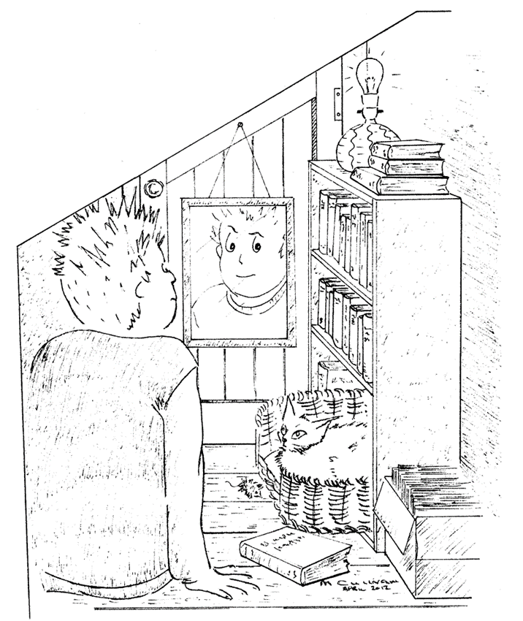
Imagine you go into a cupboard under the stairs and close the door.
There are no windows. The door is a very tight fit so no light can get in.

On the shelves are some books.
The cat is in her basket looking at you.
You can see yourself in the mirror.

You switch off the light. After ten minutes, what will you be able to see?
Which of these statements do you think are right?
For each statement, tick (✓) one column to show what you think.
Statements |  | I am sure this is right | I think this is right | I think this is wrong | I am sure this is wrong
A | You can see everything, but it is very dim.
B | You can only see the cat’s eyes.  They are shining.
C | You can only see the mirror.  It is shining dimly.
D | You can’t see anything at all.

Physics > Big idea PSL: Sound, light and waves > Topic PSL2: How we see > Key concept PSL2.1: The ‘passive eye’ model of vision
Diagnostic question
In the dark

Overview
Learning focus: | Objects are seen when light reflects off them into our eyes.
Observable learning outcome: | Illustrate how non-luminous objects can be seen when light reflects off them and enters the eye.
Question type: | Confidence grid
Key words: | Light, dark

P | PRIOR UNDERSTANDING  This diagnostic question probes understanding of ideas that are usually taught at age 5-11, to aid transition from earlier stages of learning.

What does the research say?
Ramada and Driver (1989) found that many students did not recognise that light is necessary for vision. This is perhaps because many students have never had the experience of total darkness in which they have been completely unable to see objects. In a study of 13-year-olds (n=47) it was found that 17% thought people could see in the dark and 65% though that cats could (Fetherstonhaugh and Treagust, 1992).
This question can identify whether students hold any of these misunderstandings.
Ways to use this question
Students should complete the confidence grid individually. This could be a pencil and paper exercise, or you could use an electronic ‘voting system’ or mini white boards and the PowerPoint presentation.
If there is a range of answers, you may choose to respond through structured class discussion. Ask one student to explain why they gave the answer they did; ask another student to explain why they agree with them; ask another to explain why they disagree, and so on. This sort of discussion gives students the opportunity to explore their thinking and for you to really understand their learning needs.
Differentiation
You may choose to read the questions to the class, so that everyone can focus on the science. In some situations it may be more appropriate for a teaching assistant to read for one or two students.
Expected answers
Only answer D is correct.

How to respond - what next?
Students can hold any of the wrong answers from misunderstanding their everyday experiences. They may never have experienced total darkness. Fetherstonhaugh and Treagust (1992) found children were more likely to give answer A if they lived in a city, because there is a lot ambient light at night.
In the UK reflective road studs are called ‘catseyes’. Students giving answer B can be reminded that they only light up in the beam of a vehicle’s headlamps.
Mirrors can be perceived to produce light because they can make a room brighter by stopping the absorption of light by a wall.
If students have misunderstandings about what they can see in total darkness it can help to introduce them to what this is like. If they close their eyes it is dark, similar to levels they may be used to. Placing their hands over their closed eyes makes it darker. Additionally leaning down and placing their face on the desk makes it darker still. Each time ask them what they are aware of. Initially they may be able to tell if someone walks in front of the window, but not in the last case.
The following BEST ‘response activity’ could be used in follow-up to this diagnostic question:
- Response activity: How do we see?
Acknowledgments
Developed by Peter Fairhurst (UYSEG), from York Science activity PLC3.2a: Dark room.
Images: Mary Cullivan for York Science
References
Fetherstonhaugh, T. and Treagust, D. (1992). Students' Understanding of Light and Its Properties: Teaching to Engender Conceptual Change. Science Education, 76(6), 653-672.
Ramadas, J. and Driver, R. (1989). Aspects of Secondary Students' Ideas About Light, Leeds: University of Leeds Centre for Studies in Science and Mathematics Education.

